SUPERSTORE SALES & PROFIT ANALYTICS DASHBOARD

Project Overview:

The Superstore Sales & Profit Analytics Dashboard was developed using Power BI to analyze retail business performance across sales, profit, customers, products, and regions. The dashboard transforms raw transactional data into meaningful business insights that support decision-making and performance monitoring.

Project Objective:

The objective of this project is to build an interactive Business Intelligence dashboard that helps management:

- Analyze sales performance across regions and product categories.
- Evaluate profitability and profit drivers.
- Understand customer purchasing behavior.
- Identify top-performing and underperforming products.
- Compare regional business performance.
- Generate actionable business recommendations.

Business Problem:

Retail businesses generate large amounts of transactional data every day. Without proper analysis, it becomes difficult to identify profitable products, understand customer behavior, monitor sales trends, and make informed business decisions.

Management requires a centralized reporting solution that provides a clear view of:

- Total Sales Revenue
- Total Profit
- Regional Performance
- Customer Contribution
- Product Performance
- Discount Impact on Profitability

Dataset Overview:

Dataset Name: Superstore Dataset

Total Records: Approximately 9,994+

Key Fields:

- Order ID
- Order Date
- Customer Name
- Segment
- Region
- Category
- Sub-Category
- Product Name
- Sales
- Profit
- Quantity
- Discount

Tools Used

- Power BI Desktop
- Power Query
- DAX (Data Analysis Expressions)
- Data Modeling
- Dashboard Design & Visualization

KPIs Created

The following KPIs were developed:

1. Total Sales
2. Total Profit
3. Profit Margin %
4. Total Orders
5. Average Order Value
6. Top Performing Region

---------------------------------------------------------------------------------------------------------------------

Dashboard Pages

1. Executive Overview

Provides a high-level summary of business performance.

Visuals Included:

- Total Sales KPI
- Total Profit KPI
- Profit Margin KPI
- Total Orders KPI
- Average Order Value KPI
- Monthly Sales Trend
- Sales by Region
- Sales by Segment
- Top Products

2. Sales Analytics

Focuses on revenue generation and sales performance.

Analysis Included:

- Sales by Region
- Sales by Category
- Sales by Sub-Category
- Sales Trend Over Time
- Sales by Customer Segment

3. Profit Analytics

Evaluates profitability and profit-driving factors.

Analysis Included:

- Profit by Region
- Profit by Category
- Profit by Sub-Category
- Profit Margin Analysis
- Top and Bottom Profit Products

4. Customer Analytics

Analyzes customer contribution and purchasing behavior.

Analysis Included:

- Top Customers
- Sales by Customer Segment
- Customer Contribution
- Regional Customer Analysis
- Customer Purchase Patterns

5. Product Analytics

Measures product performance and business contribution.

Analysis Included:

- Top Products by Sales
- Top Products by Profit
- Category Contribution
- Sub-Category Analysis
- Discount Impact on Profit

--------------------------------------------------------------------------------------------------------------------

Key Insights

Sales Insights

- The West region generated the highest sales revenue.
- Technology products contributed significantly to overall sales.
- Consumer segment generated the largest portion of sales.

Profit Insights

- Certain products generated high sales but low profit margins due to heavy discounts.
- Technology category contributed the highest profit.
- Some sub-categories showed negative profitability and require business attention.

Customer Insights

- A small group of customers contributed a large share of total sales.
- Consumer segment was the most valuable customer group.
- Customer purchasing patterns varied across regions.

Product Insights

- High-performing products contributed significantly to revenue growth.
- Several products had strong sales but weak profitability.
- Discount levels had a direct impact on profit generation.

---------------------------------------------------------------------------------------------------------------------

Business Recommendations

1. Increase focus on high-profit products and categories.
2. Reduce excessive discounting on low-margin products.
3. Strengthen sales strategies in underperforming regions.
4. Implement targeted marketing campaigns for top customer segments.
5. Monitor product profitability regularly before offering discounts.
6. Expand inventory for top-performing products.
7. Use customer segmentation for personalized marketing initiatives.
Screenshots

Screenshot:1

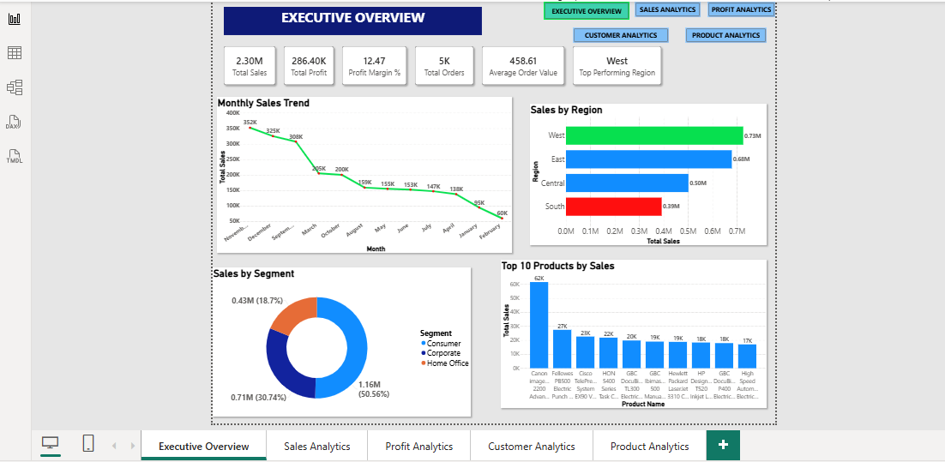
Executive Overview
Total Sales: 2.30M, Profit: 286.40K
West is the top-performing region.
Consumer segment contributes the highest sales.
Sales are driven by a few top products.

Screenshot:2

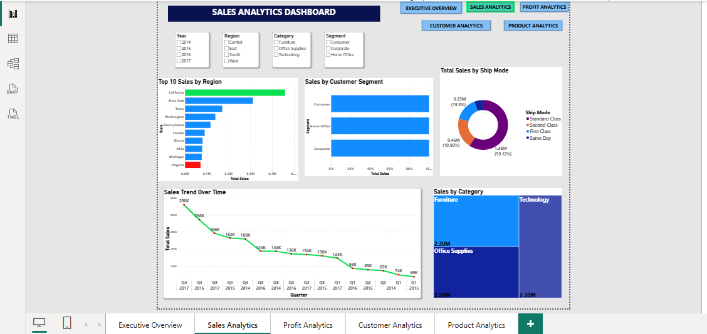
Sales Analytics
California has the highest sales.
Consumer segment generates maximum revenue.
Standard Class is the most used ship mode.
Sales peak during Q4.

Screenshot:3

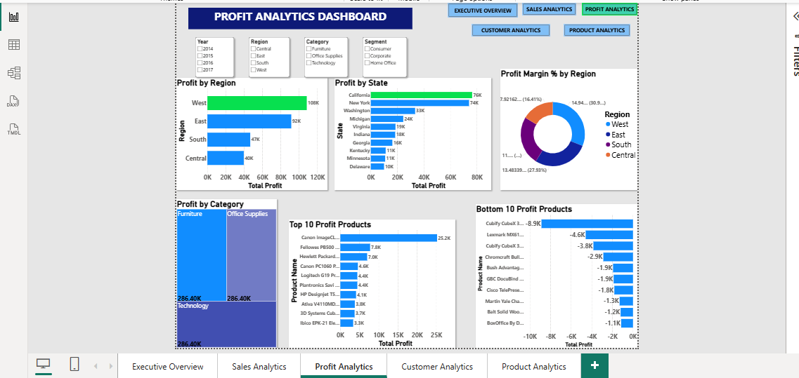

Profit Analytics
West region earns the highest profit.
California is the most profitable state.
Some products generate losses.
Higher discounts reduce profit.

Screenshot:4

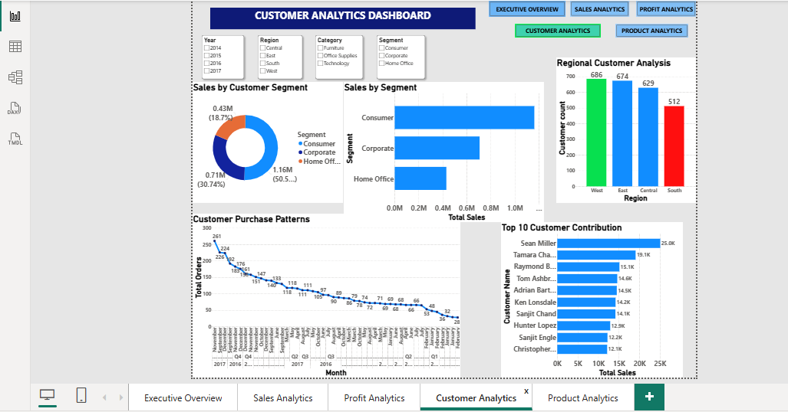
Customer Analytics
Consumer segment has the highest sales.
West region has the most customers.
Top customers contribute significantly to revenue.
Customer purchases vary by season.

Screenshot:5

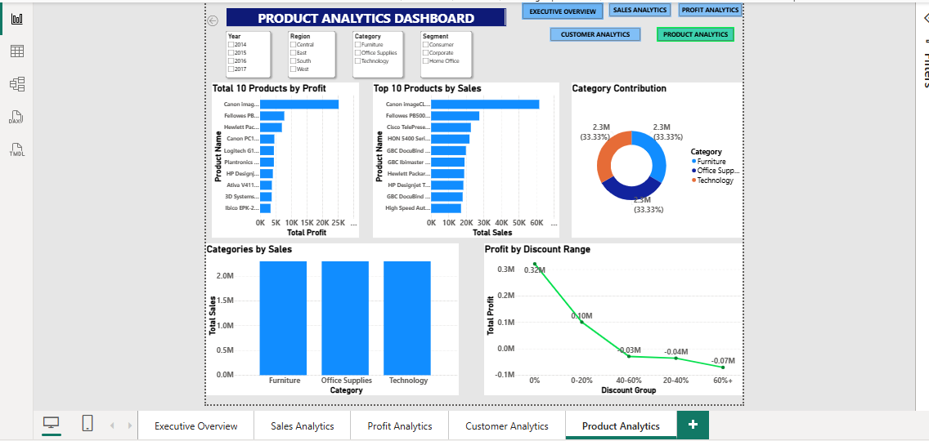
Product Analytics
Canon products lead in sales and profit.
Technology is a strong-performing category.
High discounts result in negative profit.
A few products drive most of the revenue.

Conclusion:

The Superstore Sales & Profit Analytics Dashboard successfully converts transactional retail data into meaningful business insights. The dashboard enables stakeholders to monitor performance, identify opportunities, improve profitability, and support data-driven decision-making through interactive visualizations and KPI tracking.

